1. Business Overview

JstDave is currently managed by one person. Dave Meyer is a longtime enthusiast of the game development industry with routes leading back to early childhood where the interest into video game development was foreseeable. JstDave strives to keep their games and gameplay as fun, entertaining, interesting and close to the player as possible. The business is a small game studio based in Germany. Dave Meyer is the independent game creator and is single handedly responsible for every part of the game at this point of time.
The company focuses on combining video game ideas with trying to perfectionize the ideas into a (in our eyes) better state of being. The company has previously created a game but never published any game to a Platform like Steam.
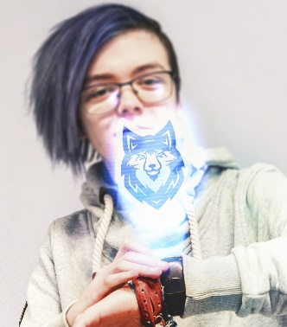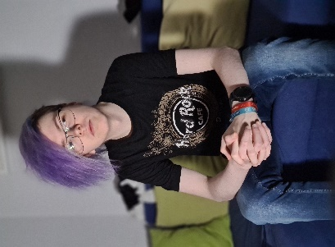
A WORD FROM THE FOUNDERS
“We’re here to give games more then just one direction in development. There are so many good ideas in games at the moment and we think that if you combine some ideas and add some own ideas to the mix you can make games that are completely new to the gaming world.”

Management team
Co-Founder – Justin Hinz
Justin Hinz is a long-time friend of mine who really helped me get into the game creation business in the first place and helped me come up with the company name in the first place. He also helps me with different decisions in game development.

Ownership & Structure
JstDave is registered as a limited liability company (LLC) since 2022 and is 100% owned by Dave Meyer.

Collaborators
Sabina Sovartsova is an artist who has been working with us since 2021 on all our projects to help develop our artistic vision. She also helps a lot with arts of the games in general.
Examples of her work:
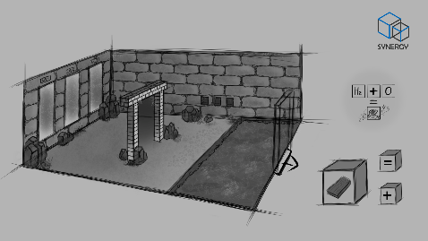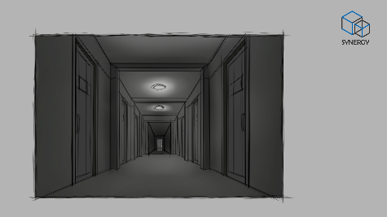

Products
Previous games and collaborations
Our previous game called “The Room” was created in late 2020 until 2021. The idea of the game is that you're stuck in a room and need to find a good way to spend the time that you have. You could watch TV, you could just lay down or you could browse the web for cat videos, it's up to you. The possible ways to interact with everything will increase over time, for now, there are just a couple of possibilities to test out the game idea.
You can find more information about the game here: https://jstdave.com/the-room
Current Development: SYNERGY.
You wake up in a hallway full of doors, not knowing where you are, who you are, or how you got here. The only thing you know is that you need to try to get out of this place and remember who you are. The only possible way seems to be
through a lot of difficult and challenging puzzles.
You can find more information about SYNERGY here: https://jstdave.com/synergy
Game mechanics:
- Visual
You first wake up in a room full of doors. These doors will lead to the different parts of the game later on if you unlock them. That means, every time a player restarts the game, he starts in this hallway again and will be able to choose in which “Level” he starts.
- Gameplay
The gameplay will consist of a level where the player pretty much spawns into. In this level the player needs to go into different Escape Rooms where the player needs to get cubes to be able to solve the problems in the overworld.
- Progression
The goal for the player is to find out who he is and to get back home. Therefor there are many hints hidden inside of the game that show where you came from and where to go to get back home.

- Concept Art
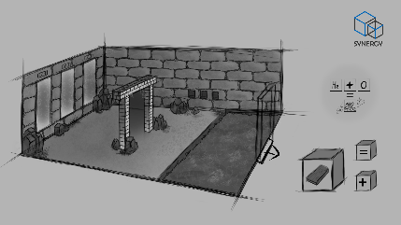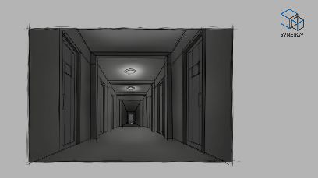
- In-Game pictures
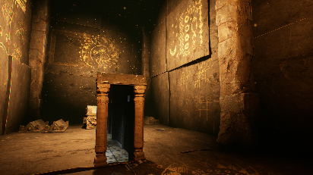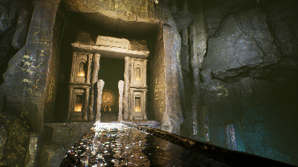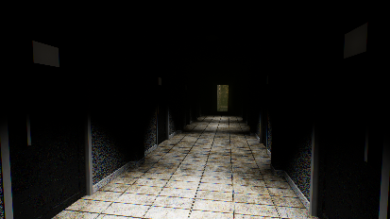

2. Opportunity

Objective
The purpose of this plan is to provide reviewers with the information necessary to evaluate the scope and future growth of JstDave in the marketplace, especially for the launch of a puzzle video game genre. In addition to serving as a roadmap for management, the plan will show that:
1. A significant market opportunity exists when analyzing the current market demands and competitive landscape.
2. The management team in place is qualified to execute on a well-thought-out operational, marketing and sales strategy.
3. The correct capital structure will allow for a long-lasting, profitable business.

Market size & segment
Global Video Game Market
The global video game market value was estimated at 159.3 trillion USD for the year 2020. It is also estimated that the market will reach 3 billion gamers in 2023 and a market value of 200.8 trillion USD.
Industry Trends: Puzzle
Based on market research made from 50,719 games available on Steam, 13373 are tagged as a puzzle game.
Industry Trends: Indie Studio
Although the qualitative "Indie" was initially a simple way of qualifying how a game was developed and marketed, it is now categorized as a trend that started in the 2000s and is still booming. The charm and popularity of indie games and their studios are transforming gamers' desires and purchase decisions. Emperor’s Studio fits into this definition of Indie development and will satisfy the needs of fans of this trend. On the other hand, the studio does not necessarily want this to be the first factor of differentiation or association.
Economic Viability
To ensure the long-term sustainability of the business, the Company will pursue the following:
- Market Expansion. The Company plans on an ambitious global market expansion and designed the game in such a way that it can easily be translated into many languages and accessible globally through the Steam platform. At some point, the company considers adapting its games to mobile and console.
- Product Expansion. The company also intends to offer various video games having a certain consistency between them and sharing common themes and universes, thus wishing to enrich their community with rare games that they love.
However, it is important to note that this business plan only considers the launch of the next video game, SYNERGY, as the first hundreds of thousands of dollars will be invested only in this first big project. A second iteration of this business plan, in a few months or years, will therefore contain a strategic planning for the development and launch of the other types of products mentioned above.

Competition analysis
Puzzle
Among the best rated games having puzzle tags, we can find:
- Escape Simulator
- Ghost Watchers
- The Room
- Inside the Backrooms
- It takes Two
- Portal
- Stray
- The Room Three
- Pixel Puzzles Ultimate Jigsaw
Development Studios
The company anticipates moderate competition from development studios of all sizes specializing in puzzle game development.
The table below present notable studios that have released at least one game of this genre.

Developer | Website | Number of games | Twitter Followers | Steam Follower | Facebook Likes | YouTube Followers | Hit | Copy Sold
Pine Studio | https://pinestudio.com/ | 11 | 2,872 | 1,226 | 1,800 | --- | Escape Simulator | >1M
Renderise | https://renderise-games.com/ | 7 | --- | 475 | --- | 374 | Ghost Watchers | 154K
Fireproof Games | https://www.fireproofgames.com/ | 6 | 9,200 | 14,437 | 32,167 | 16,900 | The Room | >6.5M

3.Execution

Development Schedule/Budget
The game that we are developing right now is SYNERGY with plans on the developing process to take around 2-3 years in general. The schedule and budget is not completely finished yet but until now we are pretty certain to meet the goals we have set for the game development process.
- 2022
Start development as well as setup a Kickstarter campaign for people to invest into our game idea.
Get a complete financing plan for the future years of development
Get a list for possible outside work to be done by people we hire
- 2023
Start getting people to playtest the Alpha Version and test if the idea makes sense in the current game market and if people like the idea itself
Finishing the Alpha to get into the Beta stage of the game
Maybe publishing the Beta to Steam for even more people to playtest the game
- 2024
Start rolling out the final updates until the game presentation / publishing stage
Start doing marketing for the game on social media like TikTok, YouTube, Facebook, etc.
- Late 2024 – 2025
Publish the game

Technology, Software and Tools
We are going to mostly use Blender as well as the Unreal Engine and substance for game development. Because of the low budget we have at the beginning we are going to need to use free software and tools as much as we can to keep the cost of the development process down.
Me (Dave Meyer) as a main developer and level designer of the game is going to use my current computer that I have already to be able to handle everything depending on the actual game development so no extra computer is needed now. You can see my hardware here: https://jstdave.com/hardware.

Location & Facilities
For the time being JstDave would remain working from home. A studio is in my opinion not needed because it would skyrocket the actual cost of creating the game where we could just use the home we are in right now for lower cost in general.
If the game idea and the game itself is getting more funds then expected we might be able to rent a studio for more employees and better workflow in general, though. This option will be held opened for the time being with the first plan to stay working from home.

Sales plan
Right now, Synergy will be sold on multiple platforms to try to establish the biggest platform for players to start noticing our game and idea. If a company like Epic Games comes forward to financing the game and helping in game creation this plan might change in the future but for the time being, it is planned that we are going to sell on platforms like Steam, Epic Games and GOG.
Synergy will be on sale through the Steam platform at a price of 24.99 Euro.
Synergy will be on sale through the Epic Games platform at a price of 24.99 Euro.
Synergy will be on sale through the GOG platform at a price of 24.99 Euro.

Marketing plan
JstDave’ marketing objective is to establish a branding among video gamers, especially those who prefer the puzzle genre. JstDave will launch a systematic digital marketing campaign that will generate awareness and sales of the studio’s games.

Marketing Objectives
JstDave’ marketing objectives are to:
- Solidify brand identity as a notable studio in the specific genre of puzzle
- Secure sales of the games and product
- Highlight the company’s commitment to continuous product improvements that meet the specific needs of its community and customers
- Increase and maintain the number of players within the community of JstDave
- Start and increase the fan email list
Video Game Marketing Campaign Strategy
In order to attract as many players as possible and generate a rapid return on investment, the marketing strategy will take shape in several facets.

The website showcases, among other things, the latest news about Synergy. Text content and articles will help the company to stand out on search engines for its own games and products, but also for certain concepts associated with them such as genre (puzzle), style and universe. It will also be the ideal place to issue press releases so that bloggers, journalists, and the media can access all the information needed to disclose it.
Each of these pillars of the marketing strategy can be dissected on a time scale which translates into three main categories explained below: before the launch of each game, the day of the launch and after the launch.

Pre-release marketing tactics
Steam store page, tags and notification. For each studio’s game that will be released on Steam, including Synergy, a page for the game will be created before the game is released. It will contain all the information that identifies the game, three screenshots and its characteristics so that it can be discovered by the gaming community, including thematic, gameplay, art style, and sub-genres. The potential customers can add it to their Wishlist, and steam will notify them when it will be released and available to purchase. The potential customer will also be notified if the game is discounted, and she/he has not purchased it yet at that moment.
Developer announcements. Announcements will be made from the website, but also through the Steam system, to share the progress that is gradually leading to the big day of the launch. It's a way to create and maintain the "hype" before its release, and to be able to interact with the community that is interested in it.
Steam Store Widget. Steam provides a way for developers to integrate a widget into their website that displays a short description of the game and links to the Steam purchase page. When the latter has not yet been released, we can then see the "Add to Wishlist" options and this becomes a way of quickly creating a link when a potential player goes to the website with her/his Steam Wishlist, thus strengthening his commitment to the purchase.
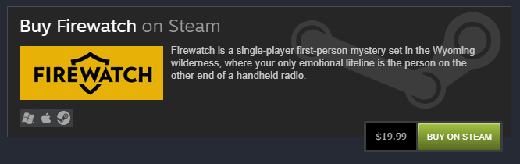
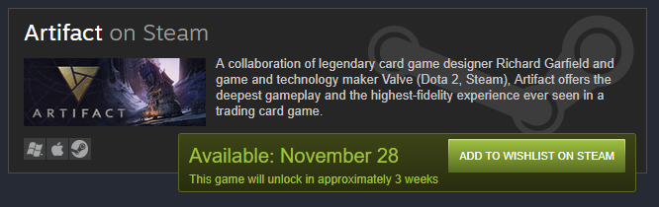
Picture above to be changed to Synergy as soon as it’s modified on the website.
Language and translation. All dialogues will be in json for easy translation. Thus, the game benefits from increased visibility towards players speaking one of the languages into which the game will be translated. Thus, by considering all non-English speaking players who represent 58% of Steam users, JstDave is strengthening its place in the market and securing market share that is impossible otherwise.
At the moment we’re not including voice actors into the financial aspect, because we don’t have voice actors planned for now.
'Coming soon' Steam Page. A "Coming Soon" page will be created so that the game can appear in the steam search and that players can add the product to their Wishlist. Then they will be notified on the launch day.
Connect with Steam Curators
JstDave will contact Steam curators from the platform's already integrated tools that allow 100 curators to be offered keys for their members to review the game. Therefore, the company will carefully choose the best 100 curators who have the best profile and audience aligned with Synergy.

Release Day Marketing
Streaming. On the very days when the studio will launch its games, the official JstDave Twitch channel will be live and broadcast the gameplay. In order to accentuate this hype, the company will sponsor influencers to play live on their own Twitch channel as well.
After Launch Marketing
JstDave is aware that the launch of the game is not the finish line, but rather the start line. All the work and planning done previously will allow better visibility and launch of the game and will also facilitate the progress of the next marketing efforts below.
Steam Organic Visibility. Steam explains in its developer documentation that when a game is successful, it could be shared on the platform's main page. We therefore speak of the principle of "organic visibility". Concretely, the sections on Steam are as follows:
- News and trends
- Top Sellers
- Promotions (when activated)
- Friends’ news feeds when the purchase of the game is made, screenshots are shared, and achievements earned
- The discovery queues
In addition, for each major update, if there is any, JstDave will create and share its patch note with the Steam community in order to benefit from increased visibility of the platform, which Steam sometimes calls "Update Visibility Rounds".
Beyond all this, a "standard" visibility is offered through the Steam catalog based on the tags and style of each studio game.

Influencers
The number of unique channels streaming on Twitch reached 10.6 million in 2020 (Q3) while 913,000 unique channels streamed to YouTube Gaming the same year, reaching 100 billion hours of video game content watched on the platform. Therefore, among the highest marketing priorities of the studio are the promotional campaigns that will be carried out by some of these influencers for the studio, in the form of contracts and sponsorships. JstDave will carefully select the channels that are most likely to contain an audience interested in the company's games in order to obtain the best return on investment.
A comprehensive tactical plan will be developed to effectively execute this marketing aspect. This will include among other things the communication strategy with influencers (what will be presented and “how”), an exhaustive list of interesting influencers with information on their channel (to get in touch in a personalized way) and the follow-up method.
Social media & Advertising
Social networks such as Facebook, Twitter, Twitch, YouTube and Discord, although they all have a slightly different function, are also a pillar of the marketing strategy at JstDave. These social networks will serve to inform fans, interact with them through various means, promote products’ launch and consistently show presence to them over a long period of time, unlike live streaming with influencers whose goal will not be to give a long-term and multifaceted experience around the studio’s universe. Some social networks like Twitter, but also Facebook, can be used to communicate relevant information for the press and journalists in order to receive press coverage.
Again, a comprehensive tactical plan will be developed to effectively execute this marketing aspect. Marketing managers at JstDave will use it to understand communication strategy, quantify objectives, perform analysis and control of various KPIs, and plan the release schedule.

Game festivals (PAX)
Participating in promotional and corporate events such as PAX, Gamescom and MomoCon Convention is part of Emperor’s Studio' marketing strategy. Although the management team knows that this will not have a direct impact on the sale of Synergy, the return on investment will come through acquiring contacts, enhancing the brand's reputation and increasing awareness among the gaming community.

Email list
A mailing list is one of the most intimate and solid ways to connect with fans in a studio. It also helps to get to know them better. With a good communication strategy in place, the studio will be able to use this powerful marketing tool in the long term.
Emails will be collected through certain interfaces in Synergy, at the request of the players who would like to subscribe. It will also be possible to subscribe via the company’s website and to receive news from the studio and free digital products.
Intellectual Property
JstDave’s games are designed to ensure the protection of its revenue-generation potential and long-term sustainability of the business. The Company has developed an IP committee mandated to establish policy and guidelines surrounding IP application and access to confidential information. The IP strategy surrounds the software algorithm, networking and database design, game play and game design elements. Therefore, the storyline, characters, arts, music, and packaging design are copyrighted.
Key metrics (KPI)
Each KPI can be further developed in the plans concerning them and by the person responsible according to the strategies and objectives evolving over time, but while keeping a modest number of KPIs so that they remain effective and meaningful. In order to achieve SMART goals (Specific, Measurable, Attainable, Relevant, and Time-bound), the following KPIs will be the most important:

- Sales
- Steam Review score and number
- Steam community and player engagement
- Steam Wishlist, paid download
- Influencers reviews and views
- Google Analytic (website and Alexa)
- Facebook likes, impressions and engagement
- YouTube views, engagement and subscription
- Backlinks from press coverage

Partnership With a Publisher
JstDave is currently working to identify video game publishers having a "fit" with the studio, its culture and its vision in order to pitch its future development projects and gather and analyze the best offers.
The company also considers the possibility of doing business with independent indie financing funds (sometimes called “syndicate”) for the advantages that this could provide in the longer term.

Milestones (linked to the Development Schedule)
- Create a detailed plan for communication, presence and visibility on the company's social networks, but also through influencers.
- Create a detailed budget explaining the allocation of funds for each of the projects and subprojects required for the development of the game.
- Setup accounting ledgers
- Plan the necessary hiring and projects (if required)
- Setup a CRM
- Create a detailed budget
- Month 1: Start of development

4.Financial Plan

Key assumptions
The following assumptions were made in order to build the financial planning:
- An amount of 120,000€ will be raised from a publisher or investors to develop and market Synergy.
- The number of copies sold by the end of Year 3 will be 73,940.
- The sales distribution of these 73,940 sales has been based on the Product Life Cycle theory.
- The sale price will be 25 Euro.
- A Steam Commission of 30% of the sales is planned for each sale.
- The proportion of games sold at a discount compared to the total number of copies sold is planned at 25%.
- The average discount of the sale is forecasted at 30%
- The portion of the revenue going to publisher is estimated at the full amount of the loan plus 25% of the sales during years 2 and 3.
- The debt owed to the publisher will be totally cleared at the end of year 3. The total amount is planned at 120,000€ (initial amount) plus 25% of the sales during year 2 and 3.
- Once the game launched, an additional amount of 30,000€ will be spend on marketing, 50% during the first 6 months and 50% for the following 12 months, mainly funded from the net profit of the sales.
- At year 3, the amount of cash, before the corporate taxes and dividends, and after having paid the publisher loan, should be of 662,943€.

Use of funds
As indicated in the financial forecasts below, 100% of the amount will be allocated to the development of the game Synergy and its marketing. The studio will raise €120,000 Euro.

Sources of Funds
Currently, JstDave is actively seeking the best editor or investor for its project.

Financial Forecasts

https://newzoo.com/insights/articles/games-market-engagement-revenues-trends-2020-2023-gaming-report/
This market report and research has been made directly from API request to public Steam database using the platform https://steamdb.info/
https://partner.steamgames.com/doc/marketing/wishlist
https://www.statista.com/statistics/957319/steam-user-language
https://blog.streamlabs.com/streamlabs-stream-hatchet-q3-live-streaming-industry-report-a49adba105ba
https://blog.youtube/news-and-events/youtube-gaming-2020/

